Investigating the Negative & Positive Impact of Technology on the Environment and What the Future of Technology Sustainability Might Involve.

Introduction:

Considering recent research such as **Kraaijenbrink *et al*. (2017)**, the looming threat of global warming and the problems it can bring, including critical issues such as difficulty with water management, puts environmental issues at a very high priority. For a sense of scale towards the urgency of this issue, **Wise (2021)**, states over 200 health journals are calling for further action in preventing a climate crisis from world leaders. This report will look at the technology industries hand in both aiding and hurting the environment.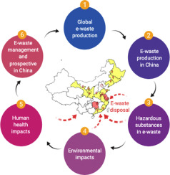

The Negative Environmental Impact of Technology/e-waste:

When considering the negative impact of technology, perhaps the biggest culprit is the e-waste its components leave behind, particularly the way this e-waste is managed. For instance, only 25% of e-waste is recycled in formal recycling centers with workers protected from the toxic substances e-waste releases **(Li and Achal, 2020)**.The volume of e-waste is one of the fastest growingsources of all global waste **(UNEP, 2007, cited by Li and Achal, 2020)**, a huge 20-50 million metric tons of e-waste is estimated each year. The e-waste pollutants are causing toxic substances in land and water, these effects are greatly amplified in areas where the highest volume of e-waste is dumped, which in many cases are developing countries within Asia. The extent of this is seen in the fact a small village, Guiyu in China, receives roughly 70% of global e-waste. This is very unethical as developed countries are dumping the burden of their e-waste to developing countries due to cost efficiency and this is leaving “severe” and “serious threats” to the local environment and general quality of life at areas around these constantly growing e-waste sites.

Figure 1- Graphical Abstract from Weila and Varenyam (2020)

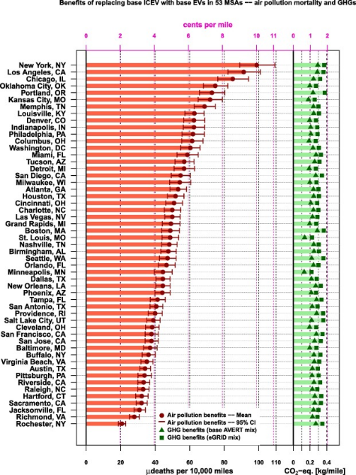**Kim *et al. (2020)*** looks at an example of a serious threat from e-waste on newborns, noticing abnormalities such as a “smaller head circumference” and implores for greater protection at e-waste sites. **Lin *et al.* (2022)** states e-waste toxicants cause cardiovascular, digestive, and respiratory related illnesses. Local environmental life such as fish are now home to many toxic chemicals due to e-waste, which is of high concern as residents of Guiyu are said to consume large amounts of fish produce. **(Xing *et al*., 2011, cited by Lin *et al.,* 2022)**

Figure - Graph to Show Benefits of EVs from Choma et al. (2020)

The Positive Environmental Impact of Technology:

To quickly touch on some pre-existing positives, one study **(Vidovic, Babic and Podobnik, 2019)** explores how automotive software has allowed much greater energy and cost efficiency, the study mainly focuses on the software’s use in EVs (electric vehicles). Similarly, **Choma *et al.* (2020)** investigates the positive effect of EVs, the study suggests the relatively modern technology leads to “substantial” health benefits and pollutant reduction. Widespread adoption EV technology has major potential to massively reduce pollutants. Further environmental benefits of technology can be seen in the development of HEMSs (home energy management systems), which employ effective planning and handling of energy around the home for optimizing efficiency, reducing “electricity prices, CO2 emission and electricity consumption at peak times”. **(Khan *et al.*, 2015)**

What is in the Future of Sustainability in Technology?

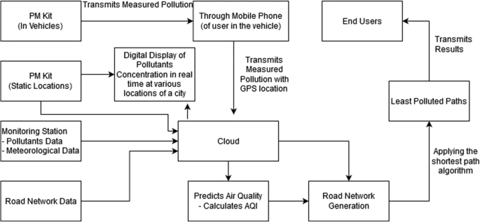There are constant studies conducted which suppose how the sustainability of technology might be improved. Many of these studies focus on the improvement of other sectors through the addition of technology, for example a recent study **(Deep, Mathur and Joshi, 2020)**, considers the fact we can merge IoT and Wi-Fi within cars, to “optimize” route planning. The article proposes how the air pollution can be measured using a “Wi-Fi-enabled airborne particle measurement system” and utilizing its readings to reduce high concentrations of air pollution via the rerouting of vehicles through a route-finding algorithm to find the “least polluted paths”. Figure 3 is an overview of how this could work.

Figure 3- Figure from Deep, Mathur and Joshi (2020)

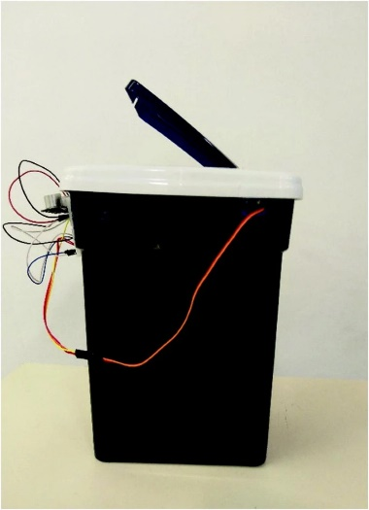

**Wanderley & Bonacin (2019)** investigate the idea of utilizing mobile and IoT technology to improve the ease at which e-waste can be disposed of ethically. Hosting a hackathon and then analyzing the results, they created a prototype for the collection of e-waste via smart recycling bins. The concept of sustainable smart cities and how IoT could be crucial in helping to achieve smart sustainability is a considerable option, the smart trash bins found in Dublin are a working example of this, using solar panels and Wi-Fi they signal if they require emptying and can automatically compact their waste. This in turn can lead to a domino effect of further benefits such as reduced routes for garbage trucks, thus minimizing the fuel pollution from garbage trucks. Challenges of implementing IoT on a broader scale includes potential technical issues with the technology such as malfunctioning sensors and even social issues such as user privacy as the technology becomes ubiquitous.

Figure - Prototype from Wanderley and Bonacin (2019)

Conclusion:

There are many reasons to be optimistic about the future of technology, however, there are also great strides to be made in the disposal and components of technology if true sustainability is to be achieved in its production and use.

**References:**

* Choma, E.F., Evans, J.S., Hammitt, J.K., Gómez-Ibáñez, J.A. and Spengler, J.D. (2020) *Assessing the Health Impacts of Electric Vehicles Through Air Pollution in the United States. Environmental International* [online]. 144. [Accessed on 02 April 2022]
* Deep, B., Mathur, I. and Joshi, N. (2020) *Coalescing IoT and Wi-Fi technologies for an optimized approach in urban route planning*. *Environmental Science and Pollution Research International* [online]. 27,pp.34434–34441. [Accessed 01 April 2022].
* Kim, S.S., Xu, X., Zhang, Y., Zheng, X., Liu, R., Deitrich, K.N., Reponen, T., Xie, C., Sucharew, H., Huo, X. and Chen, A. (2020), *Birth Outcomes Associated with Maternal Exposure to Metals from Informal Electronic Waste Recycling in Guiyu, China. Environment International* [online]. 137. [Accessed on 02 April 2022]
* Khan, A.A., Razzaq, S., Khan, A., Khursheed, F. and Owais (2015) *HEMSs and Enabled Demand Response in Electricity Market: An Overview. Renewable and Sustainable Energy Reviews* [online]. 42, pp.773-785. [Accessed 02 April 2022]
* Kraaijenbrink, P.D.A., Bierkens, M.F.P., Lutz, A.F. and Immerzeel, W.W. (2017) *Impact of a Global Temperature Rise of 1.5 Degrees Celsius on Asia’s Glaciers.* *Nature* [online]. 549 (7671), pp.257-260. [Accessed on 01 April 2022]
* Li, W. and Achal, V. (2020) *Environmental and Health Impacts Due to e-waste Disposal in China – A Review. Science of the Total Environment* [online]. 737. [Accessed on 02 April 2022]
* Lin, S., Ali, M.U., Zheng, C., Cai, Z. and Wong, M.H. (2022) *Toxic Chemicals from Uncontrolled e-waste Recycling: Exposure, Body Burden, Health Impact*. *Journal of Hazardous Materials* [online]. 426. [Accessed on 02 April 2022]
* Vdovic, H., Babic, J. and Podobnik, V. (2019) *Automotive Software in Connected and Autonomous Electric Vehicles: A Review. IEEE Access* [online]. 7, pp.166365-166379. [Accessed 02 April 2022]
* Wanderley, A.R.M.C. and Bonacin, R. (2019) *Designing Mobile and IoT Solutions for Sustainable Smart Cities. Distributed, Ambient and Pervasive Interactions* [online]. 11587, pp.212-226. [Accessed 01 April 2022]
* Wise, J. (2021) *Climate Crisis: Over 200 Health Journals Urge World Leaders to Tackle “catastrophic harm”*. *BMJ* [online]. 374, pp.2177-2177. [Accessed 01 April 2022]